J Gamboa [jeg0498]
Jeg0498@arastudent.ac.nz
Dr. Luofeng Xu
Abstract
Demonstrations of following features
Assesment 1 - Preliminary Version
BCDE211 Best Programming Practices (Web and Mobile Development)

Table of Contents
Arrow Functions 3
Sample Code: 3
Evidence used: 3
Code Reference: 3
Default Parameters 3
Sample Code: 3
Evidence used: 3
Code reference: 3
Array Functional Methods 4
Sample Code: 4
Evidence used: 4
Code Reference: 4
Template Literals 5
Sample Code: 5
Evidence used: 5
Code Reference: 5
ES6+ Classes and Constructor Methods 5
Sample Code: 5
Evidence Used: 6
Code Reference: 6
Conditional (ternary) operator 6
Code Sample: 6
Evidence used: 6
Code Reference: 7
Throw 7
Sample Code 7
Evidence used: 7
Code Reference: 7
ES Modules 7
Evidence used: 8
Code Reference: 8
Assessment 2 8

Arrow Functions

Sample Code:
(Parameter) => Body Block
functionName = (Parameter) => {Body Block}
functionName = (Parameter) => Body Block

Evidence used:

Code Reference:
Assessment 2
./triathlon/model/manager.js
(Most of the method are using arrow function.
Shorthand arrow function will be found on line 20)

Default Parameters

Sample Code:
functionName = (Parameter = defaultParameter) => {Body Block}

Evidence used:
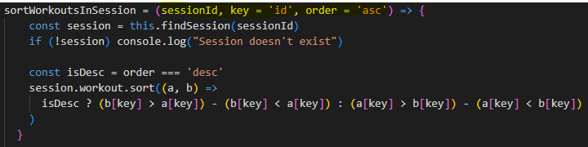

Code reference:
Assessment 2
./triathlon/model/manager.js
Line 29

Array Functional Methods

Sample Code:
Array.map(element => element.key)
Array.sort((parameter1, parameter2) => Code Block)

Evidence used:
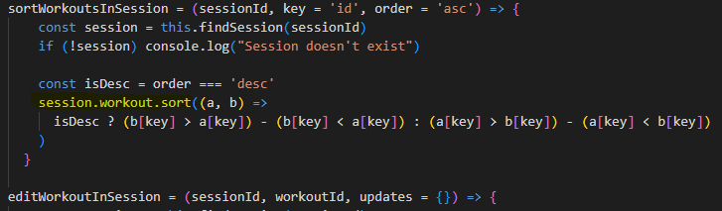

Code Reference:
Assessment 2
./triathlon/model/manager.js
Line 17 and 34

Template Literals

Sample Code:
`${Expression}`

Evidence used:

Code Reference:
Assessment 2
./triathlon/model/manager.js
Line 17 and 65

ES6+ Classes and Constructor Methods

Sample Code:
Class ClassName {
Constructor (Parameter){
This.Property = Parameter
}
FunctionName(Parameter){CodeBlock}
}

Evidence Used:
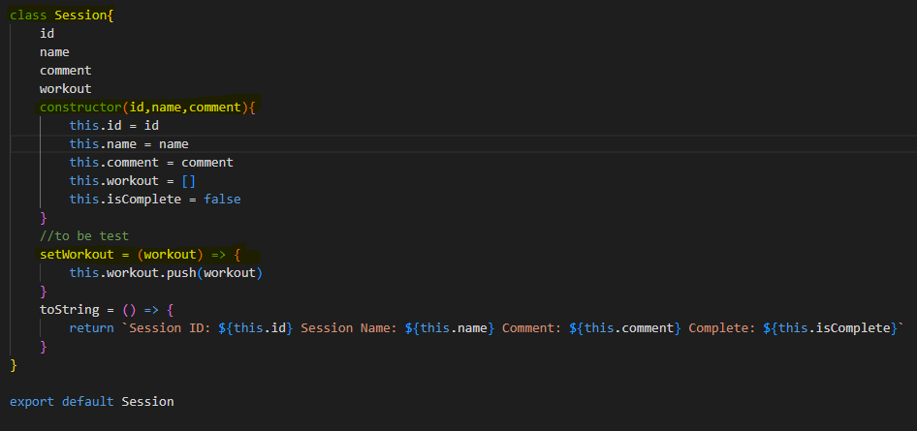

Code Reference:
Assessment 2
./triathlon/model/manager.js
./triathlon/model/workout.js
./triathlon/model/utils.js
./triathlon/model/session.js

Conditional (ternary) operator

Code Sample:
If(Condition){Expression}
Shorthand: variable? ExpressionTrue:ExpressionFalse
Else{Expression}

Evidence used:
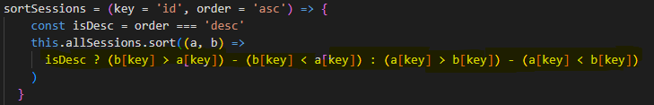

Code Reference:
Assessment 2
./triathlon/model/manager.js
Line 88

Throw

Sample Code
throw new Error('String)

Evidence used:
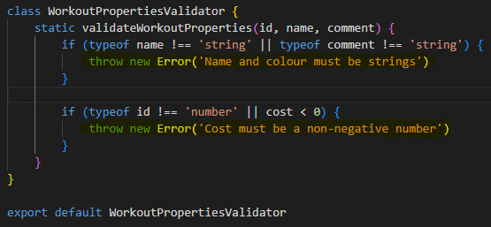

Code Reference:
Assessment 2
./triathlon/model/utils.js
Line 5 and 9

ES Modules
Sample code:
Class ClassName{}
Export Default Classname

Import Class/Method from ‘./Directory/Filename.js’
Class/Method()

Evidence used:
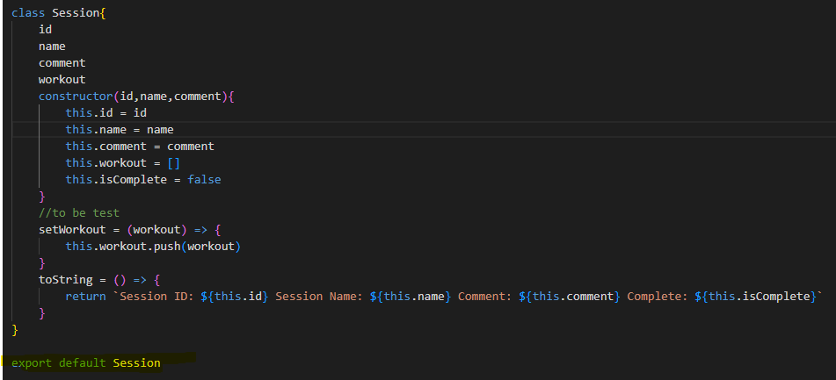
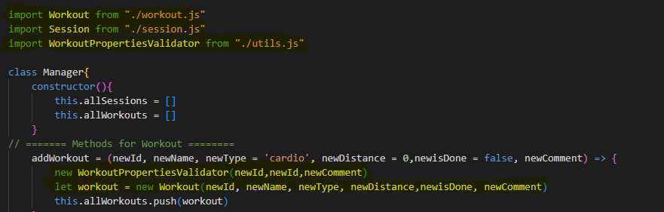

Code Reference:

Assessment 2
./triathlon/model/utils.js
./triathlon/model/manager.js
Line 1,2,3,12 and 13
./triathlon/model/session.js
Line 22

